3. Quality and Efficiency of the Implementation
3.1 Quality and effectiveness of the work plan, assessment of risks and appropriateness of the effort assigned to work packages
The fellow leads the scientific work at the sole beneficiary, HUN-REN ATK (ATK), over 24 months, followed by the AgroVIR placement (M25–M30). Five WPs connect a frozen historical-data model, two prospective processing-tomato seasons, evidence-limited software translation and career development. ELTE secondment blocks are M1–M3, M10–M12 and M16–M21 (12 months) and are locations of work within the allocated effort. Tasks are units of work that produce evidence, deliverables record that evidence and milestones make decisions, so one task may feed several deliverables. Table 1 assigns each task its months, lead, named deliverable and completion indicator (K); Table 2 gives the decision milestones and Table 3 the main risks. Effort is fellow person-months (PM): WP1 5.0, WP2 9.0, WP3 6.0, WP4 5.4, WP5 4.6 (30.0 in total: 24.0 in M1–M24 and 6.0 in M25–M30). Training embedded in scientific tasks is counted once; supervisor, partner and contracted engineering contributions are additional.
Table 1. Work packages, tasks, deliverables and leads.
WP | Task (months). Lead | Deliverable (due); indicator
WP1 Data, stress reference and frozen model  M1–M21 | T1.1 – Audit and harmonise the 2022–2026 MATE archive (units, provenance, biological identifiers, missingness, coverage); document permitted reuse (M1–M2). Lead: Fellow; MATE. | D1.1 Harmonised archive, QC record and predictor-availability map (M2; K1)
WP1 Data, stress reference and frozen model  M1–M21 | T1.2 – Define the physiological reference, Sentinel-compatible predictors and spectral conversion; lock sampling units, blocked folds, metrics, thresholds and recalibration rules before fitting (M1–M3). Lead: Fellow; Janda, ELTE. | D1.2 Locked stress-reference, predictor and validation protocol (M3; K2)
WP1 Data, stress reference and frozen model  M1–M21 | T1.3 – Build the pipeline; after the T1.2 lock, fit and benchmark the parsimonious probabilistic model (preprocessing inside training folds); freeze code, parameters and model card (M2–M3). Lead: Fellow; Hollós. | D1.4 Frozen model, benchmark, reproducible pipeline and model card (M3; K3)
WP1 Data, stress reference and frozen model  M1–M21 | T1.4 – Use WP2 diagnostics to explain sensing-scale and environmental transfer loss and define crop-specific recalibration gates, separate from the unchanged primary model (M10–M12; M16–M21). Lead: Fellow; ELTE (Jung). | D1.5 Sensing-scale and crop-transfer specification (M21; K4)
WP2 Two-season prospective field validation  M1–M21 | T2.1 – Agree primary/backup field access, irrigation contrasts, replication and valid interior-pixel geometry; align the start with two seasons; install and test soil-water and weather sensors (M1–M4). Lead: Fellow; producer, MATE, ELTE. | Field design and launch record feeding D1.2 and D2.1; MS1 evidence (M3).
WP2 Two-season prospective field validation  M1–M21 | T2.2 – Season 1: time-align Sentinel-2, soil, weather and independent physiology; archive dated frozen-model predictions, irrigation, yield and quality records; QC and exclusion log (M4–M12). Lead: Fellow; producer, ELTE. | D2.1 interim season-1 dataset and QC log (M12); MS2 evidence.
WP2 Two-season prospective field validation  M1–M21 | T2.3 – Season 2 with the same model and protocol; document weather, acquisition gaps and deviations; lock the combined dataset. UAV/proximal data are supplementary (M13–M20). Lead: Fellow; producer, ELTE. | D2.1 Two-season prospective dataset, prediction log and QC/metadata record (M20; K5)
WP2 Two-season prospective field validation  M1–M21 | T2.4 – Report unadjusted performance and transfer gap first, with uncertainty and season-level results; then evaluate labelled, prespecified recalibration on independent data (M20–M21). Lead: Fellow; Hollós, Jung. | D2.2 Transferability, calibration, uncertainty and operational-performance report (M21; K6)
WP3 DrR web MVP and placement readiness  M1–M24 | T3.1 – Inventory DrR background and data/code rights; agree workflows, interfaces, source-code delivery, acceptance tests and engineering scope (M1–M3). Lead: Fellow; Krumatic, AgroVIR. | Rights inventory and acceptance-test specification (M3), input to D3.2.
WP3 DrR web MVP and placement readiness  M1–M24 | T3.2 – Implement web shell, ingestion, provenance and uncertainty display from the fixed predictor specification; test data and research-only functions only (M4–M20). Lead: Krumatic; fellow. | Development builds of D3.1, reviewed monthly against the agreed scope.
WP3 DrR web MVP and placement readiness  M1–M24 | T3.3 – Integrate only MS3-supported functions; test numerical agreement with the frozen pipeline, invalid/stale/out-of-domain inputs and traceability; suppress unsupported advice (M21–M24). Lead: Fellow; Krumatic. | D3.1 Versioned DrR web MVP with documented use limits (M24; K7)
WP3 DrR web MVP and placement readiness  M1–M24 | T3.4 – Package release, source access, user guidance, evidence limits, test record and placement evaluation protocol; joint readiness review (M22–M24). Lead: Fellow; AgroVIR. | D3.2 Pre-placement readiness dossier and acceptance-test evidence (M24; K8)
WP4 AgroVIR non-academic placement  M25–M30 | T4.1 – Evaluate input-data requirements, output consistency, missing/out-of-domain behaviour, usability, interoperability and decision relevance using approved test/coded data and consented feedback (M25–M27). Lead: Fellow; AgroVIR. | Midpoint assessment record (M27); MS5 evidence; first part of D4.1.
WP4 AgroVIR non-academic placement  M25–M30 | T4.2 – Retest prioritised issues, document residual limitations and compile AgroVIR’s external assessment; gate-failed functions stay outside operational use (M28–M30). Lead: Fellow; AgroVIR. | D4.1 AgroVIR operational and interoperability assessment (M30; K9)
WP4 AgroVIR non-academic placement  M25–M30 | T4.3 – Define post-MSCA integration, licensing/venture and replication steps with owners, permissions, dependencies, resources and gates; MVCRI crop extension is post-project (M27–M30). Lead: Fellow; AgroVIR, ATK. | D4.2 Post-MSCA FMIS-integration and exploitation roadmap (M30; K10)
WP5 Training, open science, dissemination, management  M1–M30 | T5.1 – Agree the CDP by M3; evidence physiology, modelling, EO-transfer and research-to-software competences plus transferable skills and teaching; quarterly reviews; record the 12 ELTE secondment months (M1–M30). Lead: Fellow; Janda, ELTE supervisor. | D5.1 Career Development Plan (M3; K11), reviewed quarterly
 | T5.2 – Apply access, metadata, storage, consent and retention rules from M1; DMP by M6, updated after validation and at closure; release permissible assets with persistent identifiers (M1–M30). Lead: Fellow; ATK research management. | D5.2 Data Management Plan (M6; updates M21, M30; K12)
 | T5.3 – Dissemination, communication and exploitation strategy from M1 (documented M3, updated M24); manuscripts, conferences, practitioner engagement; result/IP inventory (M1–M30). Lead: Fellow; ATK technology transfer. | D5.3 Final dissemination/exploitation plan (M30; K13, K14)
 | T5.4 – Monthly progress/risk records, gate reviews, agreements and reporting; mobility declaration within 20 days of start; end-of-training questionnaire and two-year follow-up (M1–M30). Lead: Fellow; ATK administration. | Management records and required administrative submissions.
Completion indicators. K1 (M2): five seasons audited; every retained variable has provenance, units, availability and a QC disposition. K2 (M3): one timestamped protocol locked before fitting and before prospective outcome access. K3 (M3): one versioned primary model and one benchmark; leakage-free held-out years; a clean rerun reproduces the archived outputs. K4 (M21): reusable, scale-specific and crop-specific components and revalidation gates distinguished; no additional crop presented as validated. K5 (M20): 100% of scheduled observation opportunities accounted for as valid, missing or excluded; valid coverage and effective biological sample size reported. K6 (M21): balanced accuracy, F1, ROC-AUC, reliability, Brier score, false-alarm rate and lead time by season and pooled, with uncertainty; transfer gap quantified before recalibration. K7 (M24): 100% of agreed critical consistency and input-failure tests pass; zero unresolved critical defects. K8 (M24): dossier covers source access, rights, tests, guidance and use limits; AgroVIR confirms scope. K9 (M30): six dimensions evaluated; every prioritised issue has a disposition and residual risk. K10 (M30): roadmap states owners, IP/access, dependencies, resources and decision gates; no uptake promised. K11: CDP reviewed quarterly; four technical strands and transferable skills evidenced; 12 secondment months recorded. K12: 100% of released assets have metadata, an access decision and a persistent reference. K13 (M30): ≥2 manuscripts submitted, ≥2 conference presentations, ≥1 end-user workshop. K14 (M30): each result family has audience, route, owner, timing and indicators.
Table 2. Decision milestones.
MS (month) | Decision and acceptance evidence | Approvers
MS1 (M3) | Protocol locked before fitting; primary pipeline and model frozen before any prospective outcome access; field launch plan and CDP agreed (D1.2, D1.4, D5.1). | Fellow + ATK; ELTE/MATE input
MS2 (M12) | Season-1 observations and exclusions QC-reviewed; acquisition and field logistics adjusted if needed without changing the primary model or estimand. | Fellow + ATK; ELTE/MATE input
MS3 (M21) | Two-season primary performance and transfer gap reported; D1.5, D2.1 and D2.2 accepted; permitted MVP functions and limitations decided. | Fellow + ATK; ELTE input
MS4 (M24) | MVP and readiness dossier pass agreed critical tests within the permitted scope (D3.1, D3.2); placement evaluation scope confirmed. | Fellow + ATK; AgroVIR; Krumatic tests
MS5 (M27) | Six-dimension midpoint assessment completed; correction priorities and remaining evidence needs agreed. | Fellow + AgroVIR
MS6 (M30) | External assessment, integration roadmap and final dissemination/exploitation plan completed (D4.1, D4.2, D5.3); remaining limitations and owners recorded. | Fellow + ATK + AgroVIR
Dependencies and critical path. T1.1 feeds T1.2; the protocol lock precedes fitting in T1.3. The frozen model plus T2.1 readiness permit T2.2–T2.3, whose evidence supports T2.4 and T1.4; MS3 constrains T3.3 and MS4 permits WP4. T2.1 and T3.1 start in parallel with WP1; T5.1–T5.4 run across the action. Critical path: MS1 model freeze → WP2 prospective evidence → MS3 permitted functions → MS4 release → WP4 evaluation. The crop calendar must place MS1 before season 1 and the second harvest by M20; MS2 permits logistical corrections only. WP1 carries 1.8 PM before its M3 freeze, so archive readiness and a focused scope are essential.
Risk control. Monthly monitoring and gate reviews (T5.4) record triggers, owners and corrective decisions. Poor transfer is a reportable scientific result; it does not authorise unsupported advice.
Table 3. Risks, mitigation and owners (L/I: likelihood/impact).
Risk | WP | L/I | Trigger response and responsible actors
R1 | WP1 | M/H | Archive/sample-size or M3-freeze failure: audit at M1–M2; narrow common predictors/reference before deployment; never use prospective outcomes to repair training. Owner: fellow/ATK.
R2 | WP2 | M/H | Field/calendar failure: agree access, replication, valid pixels and backup by M3; test sensors before observations; switch to a comparable site before the crop window; downgrade claims if two seasons fail. Owner: fellow/ATK/producer.
R3 | WP2 | M/H | Sensor failure or weak stress contrast: continuous QC, spares and manual checks; physiology verifies stress; report weak contrasts and missing metrics. Owner: fellow/ATK/producer.
R4 | WP1–2 | H/H | Clouds, mixed pixels or EO access: agree ELTE access and pixel rules; log gaps; UAV is supplementary; inadequate Sentinel coverage restricts satellite-transfer claims. Owner: fellow/ELTE.
R5 | WP2–3 | M/H | Poor transfer: report unchanged-model performance first; evaluate recalibration separately; limit MVP and placement to supported functions. Owner: fellow/ATK/AgroVIR.
R6 | WP3–5 | M/M | Engineering, IP or workload delay: agree scope and source rights before development; review releases monthly; protect campaigns and narrow non-critical features. Owner: fellow/ATK; Krumatic/AgroVIR.
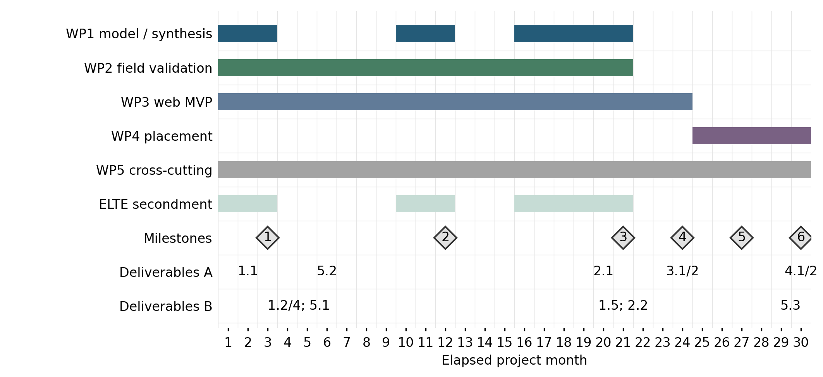
Gantt: bars show activity windows; diamonds numbered 1–6 denote MS1–MS6. Deliverable labels omit “D”; “3.1/2” means D3.1/D3.2, “4.1/2” means D4.1/D4.2 and “1.2/4” means D1.2/D1.4. T1.4 is post-freeze synthesis. Secondment and placement are shown explicitly; only elapsed months are used.

